**Dear Abdullah & Team (Code Club)**

Asalam-o-Alaikum !

With reference to the meeting held on **02 February 2026** regarding the updates and enhancement of the Peshawar Services Club (PSC) Mobile Application, we would like to formally share the key observations and requirements below. You are kindly requested to examine each point carefully and provide your **“Done”** remarks once the respective observations have been addressed and resolved.

Furthermore, a final coordination meeting with the Accounts Department will be arranged in due course to ensure clarity and alignment on financial modules and accounting-related requirements. The Accountant will convey any additional inputs, if required, to facilitate smooth implementation.

We appreciate your continued cooperation and technical support in upgrading the PSC Mobile Application and look forward to timely completion of the assigned tasks.

Please feel free to contact us for any clarification!

Assistant Secretary

(Wasif Saleem)

**GENERAL OSERVATIONS IN MOBILE APP (User Interface)  
(Sequence wise)**

**BUGS IN APPLICATION**

1. In About PSC, its briefing SD is not Correct.
2. In Announcement, “The Refresh Icon” is not align properly. In other pages its on top with title.
3. Every notification should be deep linked. Like when notification pop-up and member click on that pop-up so it should direct to that page.
4. Notification description should be rich text editor. And there should be an option for uploading PDF and Image file.
5. When we open Affiliated Clubs. Its First pop-up Appears. In that pop-up “Cross” icon is not in red color. All UI should be Same color, same shape, same size.
6. In Affiliated Clubs pop-up “How to request a Visit” appears multiple time. It should appear once, when member open its page for first time.
7. In My Bookings the title “My Bookings” color is not in black color.
8. In My Bookings “Check-out” is not align properly.
9. In View Booking it does not sow which hall is booked. Also there is no Check-in/Start or check-out/end. It should be only Check-in and check-out. No need for start or end
10. Also no need for check-out in photoshoot bookings.
11. In Invoice Details of Booking. In Invoice there is not invoice number mentioned. And there should be an option for save invoice and share invoice.
12. When member confirm its hall booking and don’t pay at that time, so there should be an option In booking details or in in voice to pay bill.
13. There is only one option in Invoice and that is to share invoice but there should be an option for pay bill or share or save.
14. When we share invoice it should not be in text format, it should be in Image or non-Edited format.
15. In “Contact US” Boxes are not correct, not in same color as other boxes in other content.
16. Timings is static, it should be dynamic
17. Homepage is not responsive for all devices.

**GUEST ROOMS:**

1. “Enjoy Your Stay with US” box is not correct. Its color is not correct. It should be same as Hall Booking Boxes.
2. Title “Guest Room Policy” is not correct. It’s in black color which is not correct.
3. Check-in 1400 and Check-out 1200 is not properly aligning. And whenever I try to align it it goes back to its normal or current state.
4. Features are not properly aligning with bullets.
5. Extra spacing in all content should be remove. For example, inside guest room BOOK FOR GUEST spacing is way to more.
6. In Booking Invoice, Pending Icon is in green color which is not correct. It should be in red color as I other content it’s in red.
7. “Complete Payment Now” button is not correct. Specially its color.
8. Amount should not be in decimal format like 90000.00. in this .00 is not required. Same as in other content its not required.
9. Whenever I click on “Refresh Invoice” App Crashes, I go straight to my mobile home page not even in app homepage.
10. There should be proper mobile number format. It should not take 123 or 000 etc as a mobile number. It should be standard mobile number format. Use this in other contents too.
11. In “MY Booking” After clicking on “Rooms”, When member book for guest it should show which room he looked like studio, deluxe, suite. And “Guest: Room 406” this is not correct, in this field it should be Guest Name like “Guest: Ali” not room number.
12. In “My Booking” “In Rooms” No need to re-write “4 room bookings found” as its shown on top in a box. Same for all content like 4 halls booking found etc etc.

**MESSING:**

1. Headings and text should be same as Hall Booking Policy. In sense of color size shape etc.
2. No Need of Box of Dress Code. Which is in white.
3. Background color is not correct. It should be same as other content.
4. Button color is not same as other content.
5. Item names are in regular format whole price is in bold.
6. There should be an option for admin to give order number to menu or sequence.
7. Sequence is very important. There should be an option for admin to sequence it or order it in his manner. Same for all other content like in sports, lawns etc.
8. F&B page is freeze, it should scroll up or down.

**SPORT & ACTIVITES:**

1. There should be an option for admin to rearrange activities sequence.
2. “More About and Overview” should align properly and make them proper buttons. Like in “Photoshoot” Booking Type buttons.
3. Rates or pricing should not be in decimal format like 300.00. no need for .00.
4. In every content you used “RS” for amount or price but in activities you used “PKR”. So it should be RS.
5. “Cross Icon” in sports and activities is correct. So use same cross icon In every place or in other contents. Where needed.

**HALLS**:

1. Use same background color, same format, same size like hall first page.
2. Every content or field should be same as hall page.
3. Its policy format is good so use same color and size in other contents too. Like Guest Rooms, Sports etc etc.
4. When I select 2 dates like 4 feb and 5 feb then in below I am not able to select Event time. Its Drop down is stuck in other box. And not working properly.
5. When member book complete banquet hll so other members should not be able to book any other or lawn on same date or same time. When they try to book a pupup should appear which states that this date is booked and for further detail contact booking office.
6. But but but admin should have the power to book banquet hall or lawn on same date or time via web portal. But not member had that authority
7. Total amount box is very large in size.
8. Confirm booking page is not in proper format like cancel button color is not right and not align properly.
9. In Event type no need to show cooperate event. But in web portal there should be an option for cooperate event and price.
10. In booking details. Only hall is written when I booked conference room. So type should be specific that name which member has booked.
11. When member book a hall but after confirming his slot he didn’t pay and go back. So where should he find his voucher number or consumer number. In invoice there should be an option as voucher number or consumer number from which he pay his advance fees.
12. Banquet hall advance is 50k minimum. Where others halls which cost is less than 50k should pay full fees like in engle bright hall dining hall conference room.
13. Same issue, box color and text color is not correct in “Important information” its in blue color but in other content its in yellow color.
14. In Hall invoice, “Pending Icon” is in green color which is not correct it should be in red color as in other contents its in red color.
15. While booking after selecting date in event type its written “ configuration fro….” Instead of this write booking details or remarks.
16. In event details no. of guest already written by default. Don’t write that, write it as a guidance also write maximum no.of guests is 28 in brackets. Same as other contents.
17. Also write for more details contact booking office 03419777711.

**LAWNS:**

1. Lawn booking policy title is not correct. Its color is not right.
2. Sequence in with canopy category is not right.
3. Admin should have an option to rearrange that sequence.
4. Same points as hall booking.

**PHOTOSHOOT**:

1. Book Now Button color is not right.
2. Booking time doesn’t reflect properly in web portal.
3. Timings are not correct for photoshoot.

**FUNCTIONAL OBSERVATIONS / REQUIREMENTS**

## **Mobile App (React Native)**

### **1) Authentication & Access**

* Login via OTP (SMS/Email) for pre‑approved members only
* JWT-based session
* Role-based access (Member/Sub‑Admin/Super Admin), comprehensive admin control over all operations. (We can give module wise access to user on App with ‘View/Add/Delete’ rights both in App and Web Portal based.
* Force logout if the Admin/Sub Admin user deactivated.
* Force logout if the Member user deactivated (forcely Deactiviate A members due to some App activities) also he can Not Login/Login/Booking based on provided Member status. (As provided members status).

### **2) Home & Content (CMS)**

* Facilities listing (images, description, availability)
* Events list
* Club Rules (formatted, scrollable)
* Announcements (read/unread status) for members. (Notifications must be deep linked)
* About Us page
* Promotional ads carousel
* Messing, Sports, Contact us.
* Aff Club list can be sorted
* All the above content should be dynamic and can be sorted based on (category and listing), support rich text editors, images, PDF Files.

### **3) Facility Booking**

* Guest Rooms: check‑in/out, occupancy, rates.
* Banquet Halls: date/time slot, capacity, features.
* Photo Shoots: date/time, duration.
* Availability check (hide blocked/occupied slots).
* Booking form with guest count & notes.
* Booking ID and Consumer no/Voucher no generation.
* Booking Status: Pending, Half Paid, Initial Payment, Paid.
* Payment Status: Pending, Paid, Expired, Cancelled (If Booking has been marked canceled before expiry).
* If booking cancelled before expiry → Payment Status = Cancelled
* T&C acceptance before submit.
* All Booking select “Type Radio Button -> Member -> Guest.
* In Sports, Messing, Events, Announcements (For more information please contact us on “contact number”) can update number information dynamically.
* Feedback/Suggestions screen in App along with status updated when reply on that by Admin. Notify that user when the admin adds a reply to the message.
* Report of all or specific feedback can be search by Status wise category wise from and to date wise and view and download and export option.
* Cn no /Book no reflect all screen of apps and web where the information show the book no and con no must be view on all screens.
* All forms inputs fields must be validated and follow min max formate as per standards.
* Admin can reserve room date wise and multiple dats reservation also admin can change reservation into booking. Reservation editable.

### **Guest Room.**

1. Can book for member Guest and Arm forces and Non Members “Aff Club members”.
2. Booking status and payment of voucher generation, total payment, pending, paid, Unpaid maintained properly → on booking and payment extended, reduced rooms, changes of dates, Type from Members guest and Arm forces reflect properly.

**Advance Payment & Refund Policy**

| **No. of Rooms** | **Minimum Payment** | **Cancellation  (Advance payment Non-Refundable)** | | | |
| --- | --- | --- | --- | --- | --- |
| **Informed Before 72 Hrs** | **Informed within 72 Hrs** | **Informed within 24 Hrs** | **Unoccupied Room** |
| Upto 2 Rooms | 25% | 5% | 10% | 25% | 100 % Room rent will be charged in member’s monthly Bill |
| Upto 3–5 Rooms | 50% | 15% | 25% | 50% | 100 % Room rent will be charged in member’s monthly Bill |
| Upto 6–8 Rooms | 75% | 25% | 50% | 75% | 100 % Room rent will be charged in member’s monthly Bill |

***Important Note***

*Members are required to initiate cancellation requests through the PSC Mobile App and inform the Guestroom Reception for confirmation.*

*In case a member fails to initiate the cancellation request or does not inform the Guestroom Reception at* ***091-9212753-4 / 0345-8518696****,* ***NO REFUND*** *will be entertained, and charges will be applied in accordance with the above policy.*

### **4) Payment (Kuickpay)**

* Voucher generation API

### **5) Booking Management**

* View active bookings
* Filter by facility/date
* Cancel own booking

### **6) Monthly Billing**

* Bill summary (month, due, balance, total)
* Status: Paid/Unpaid/Partial
* Payment history with transaction details.
* **Upload All monthly Bills PDF Files (it will save Month Year wise) latest month bills will be shown to members in App also he can see back aval months monthly bills can download the bills.**
* If he want to pay he can pay the bill using kuickpay voucher.
* Reports of paid voucher and total amount members wise payment report will be generated and can view download as psd and excel format along with all necessary information related to these payments.
* After payment of monthly bills Members have that voucher in App unpaid voucher also viable by member and Admin in web also serarete report can be printed download as pdf and excel.
* Payment history (App user member can see view past payments, transactions, Payment date, Amount, payment method, This data will be reflected and cover all payment paid and bills information in member add it to bills or paid any amount in club.

### **7) Notifications/Announcements**

* Push notifications (events, reminders, alerts)
* Foreground / background / on‑tap behavior
* Notification history
* Announcements support rich text editor data, PDF Files.
* Auto notify users on the last 15 minutes left on their booking expiry and on click th deep linked to the booking details in App.

### **8) In‑App Admin**

* Separate admin login
* Dashboard stats
* View all bookings
* Calendar view for all booking and status wise properly search and reflect data. Mention exact counts instead of 9+ and on clic view the required booking or other information.

**App ISSUES (Guestrooms)**

1. Cancel Booking Listing
   * A proper listing should be available to view all cancelled room bookings.
2. Voucher Number in Pending Status
   * When a room booking is in Pending status, the voucher number should be visible (currently it is not showing).
3. Bill Payment Status Validation
   * For bill-payment bookings where the room amount is PKR 9,500, if the user pays PKR 10,000 via the provided Postman API, the room still gets booked despite the mismatch. This needs validation and clear payment status handling.
4. App Crash on Voucher Refresh
   * After clicking Book Now, the voucher screen appears. Clicking the refresh (arrow) icon causes the app to crash.
5. Consumer Number vs Voucher Number Confusion
   * Example: Consumer Number is 254300000000000000106 and Voucher Number is 975677622066. These are different numbers. Clarify which number is used as the unique reference for payment comparison and reporting.
6. Show Tracking Numbers on All Screens
   * During the booking process, display the Consumer Number and/or Voucher Number on all screens so the user can track payments if status is delayed.
7. Display Consumer Number in Web Portal
   * Show Consumer Number along with booking status and payment details in the web portal. Present payment information in a user-friendly format, such as:
   * Amount Paid: PKR 9,500
   * Billing Month: Jan 2026
   * Bill Status: Paid
   * Transaction Auth ID: 787965
8. Room Number After Payment Confirmation
   * The assigned room number must be displayed in the user app after payment is confirmed.
9. Deep Linking for Notifications
   * All booking-related and announcement notifications should support deep linking to open the relevant screen directly in the app.
10. Booking Expiry Reminder
    * Users should receive a reminder notification 15 minutes before booking expiry.
11. Transaction Record Retention
    * Any booking with a payment transaction should never be permanently deleted. Provide a separate listing (Web & App) with filters such as:
    * Cancelled before payment
    * Cancelled after payment
12. Expired Booking Listing. Expired booking reservations should have a separate listing in the web portal.
13. Inconsistent Payment Status
    * The system sometimes shows "Half Payment – Confirmed" and other times "Full Payment – Confirmed" for similar scenarios. This needs consistent and clear logic.
    * 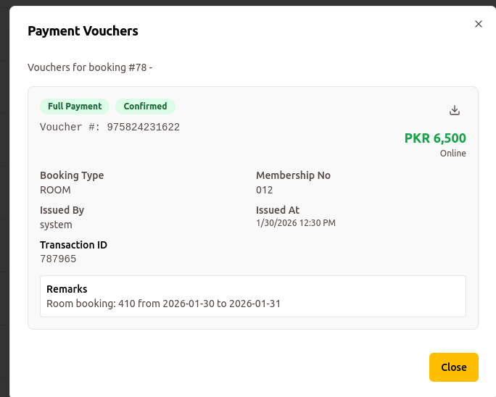 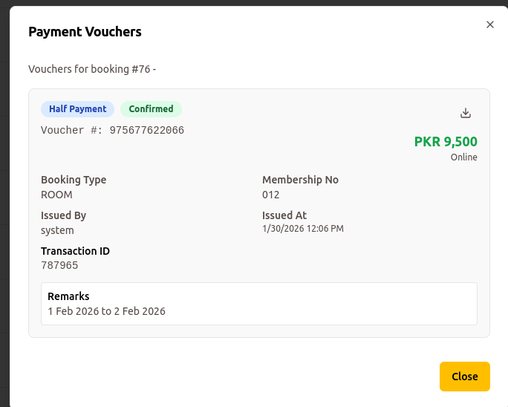
14. Incorrect Amount in Booking #80
    * Booking #80: User initially booked 1 room, admin added another room (total 2 rooms, price PKR 13,000). The web portal incorrectly shows only PKR 6,500 in booking details.
15. Incorrect Full Payment Confirmation – Booking #81
    * Booking #81: User booked 1 room, admin added another room later. User paid only the voucher amount for 1 room, but both web portal and app show Full Payment Confirmed, which is incorrect.
16. Payment After Admin Cancellation
    * A user booked a room that was later cancelled by the admin. After cancellation, the user still paid using the provided consumer number, the payment was processed, and the user received confirmation. This requires validation to prevent payments on cancelled booki ngs.
17. Manage Room Maintenance
    * Add New Maintenance Period (Failed to Update the room). Clear reason instead of failed message.
    * 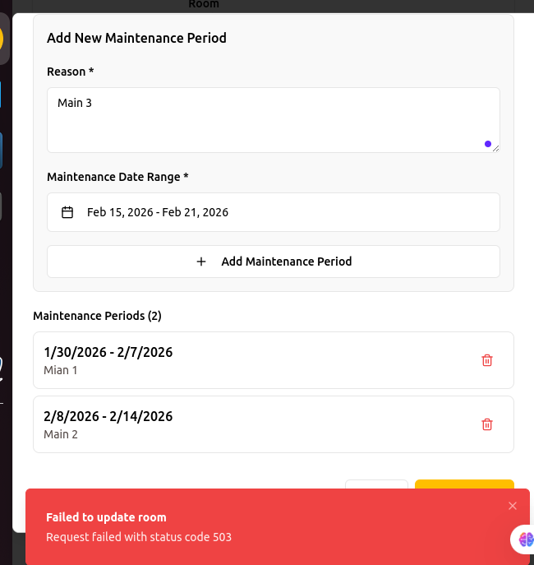
    * Existing Maintenance room duration can’t be edited. in case we want to change the maintenance schedule date. Here I need the edit option.
18. Create Room Booking by Admin
    * Admin Select payment method cash or online transfer when book room.
    * Arm Forces Ref information used for red of booking in case of Arm forces guest the guest information fields must be filled by admin in booking time.
19. Check Reservations for rooms
    * More than one room reservation must be handled before payment, in case dates extend, reduce and same room extend or reduce by admin after or before payment. If not then make a way out with (PSC Management) for easy to handle and manage. Currently I need to work on this and manage all possible scenarios based on user app and admin portal based functionality.
20. App admin Side
    * Calendar view all types of data not reflected properly in calendar views.
21. Previous Doc shared (Demo Day points)
    * All mention points.

* 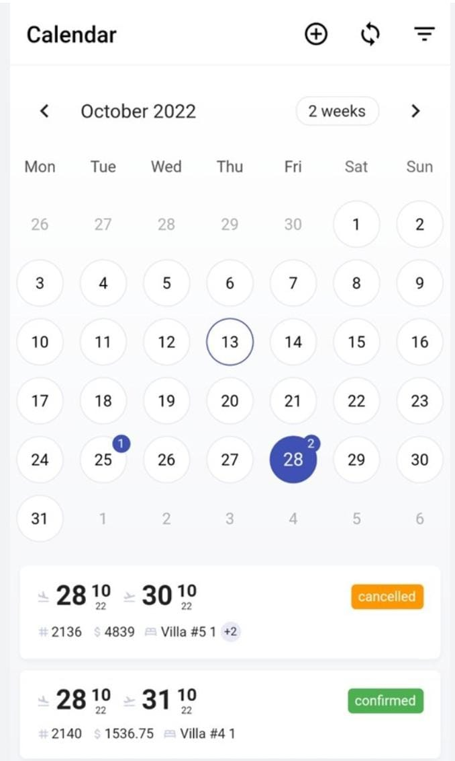
* Filters by facility/date/status
* No edit/approve/cancel actions

## 

## **Web Admin Panel (React.js)**

### **1) Admin Authentication & Roles**

* Super Admin / Sub‑Admin roles
* Role-based permissions
* Force logout on deactivation

### **2) CMS / Content Management**

* CRUD: Facilities, Events, Club Rules, Announcements, About Us
* Promotional ads with scheduling
* Rich text editor
* Media library (image/PDF)
* Content preview + version history “Admin can see created by modified by every content”)

### **3) User Management**

* Add new members manually and can be Import/Export by Excel sheet.
* Activate/Deactivate members
* Assign roles (Member/Sub‑Admin/Super Admin)
* Sub‑admin read‑only, read and bookings,Management (blocked/Unblocked, Activated/Deactivated) Cancelled, Dashboard and Reports module wise access. Module we have Dynamic contents, Guest Room, Photoshoot, Halls and Lawns, monthly Bills, Members information, Notification adn announcements.

### **4) Booking Management**

* View all bookings in real‑time.
* On New booking Admin received notification in App and Web Portal. On view that notification it will be read, unread room notifications/announcements will be listed. Apply on all types of booking rooms and halls and photoshoot.
* Filters by facility/date/status/member
* Manual booking creation (Admin based on access) Booking status and payment of voucher generation, total payment, pending, paid, Unpaid maintained properly → on booking and payment extended, reduced rooms, changes of dates, Type from Members guest and Arm forces reflect properly. Advance Payment & Refund Policy apply as mentioned above for App.
* There should an option to add Rent, Food, mattress, Laundry, GST and Svc Charges in admin panel (web portal) on room booking or same data of mentioned fields should be reflected from MIS in final settlement (reflects in all required reports including mobile app for users, mobile ap for admin and web portal)
* Admin have option can pick Payment method voucher generation if kuick pay, ask cheque along with cheque information, pay by card along with tr id, date and bank, ar exp date, To Biil, online transfer along with tr id, date and bank.
* Room cancellation request by member from App and view by Admin, Admin can approve the cancellation request. Log will be maintained as mentioned.
* Before 72 hours and 24 hours alerts to admin about book rooms remaining payment status confirmation.
* Pending payment visibility.
* Booking calendar Room wise report like  
  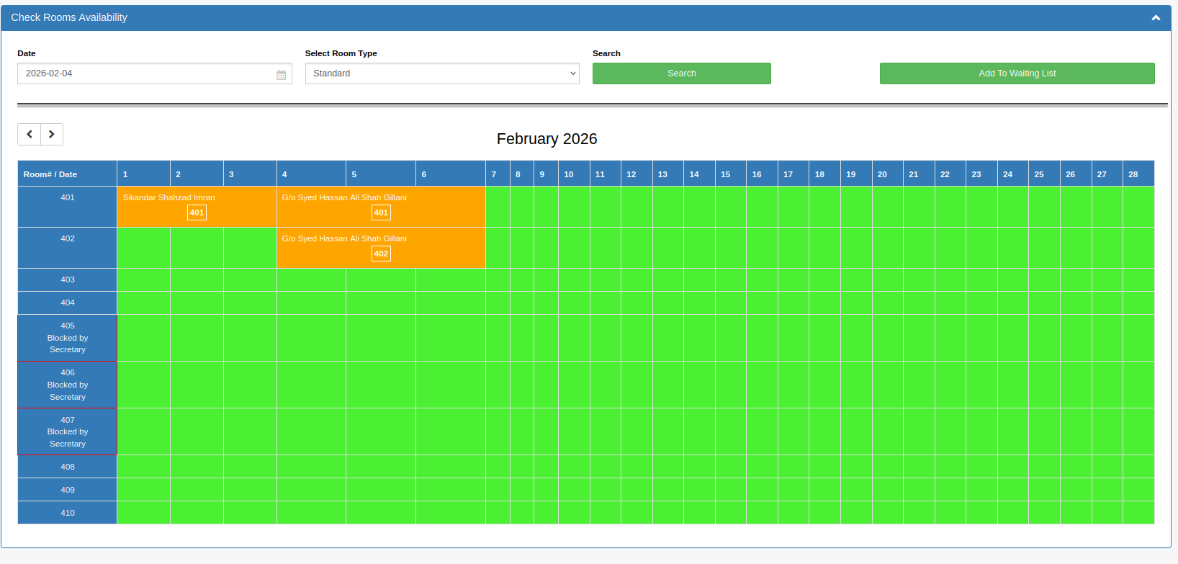
* In Guest Room reports date multiple search room booking status (Booked/Canceled/Occupied) wise, payment wise from and to date, Room Type wise, Specific room wise user booked by wise (App/Admin), member no wise, canceled by wise, Booked for wise, occupancy
* Room Monthly Checkout Report (Date Range From and To based)
  + 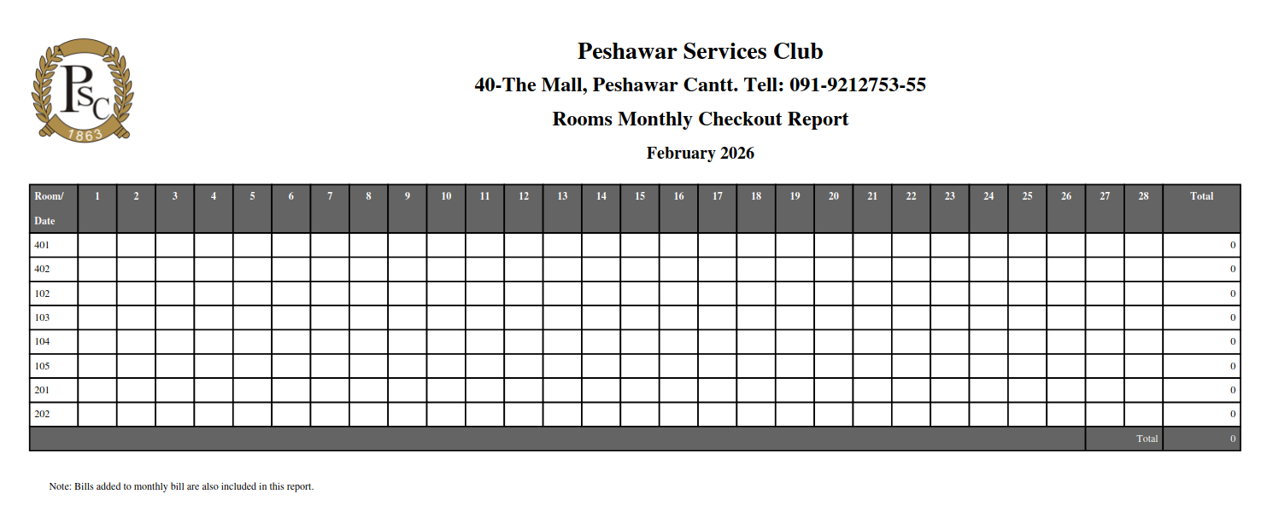
* Room Daily checkout Report search by date
  + 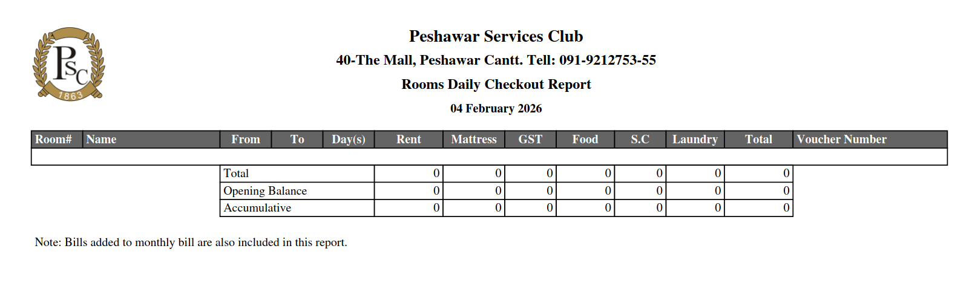
* Guest Room's Sales Report (Date Range From and To based)
  + 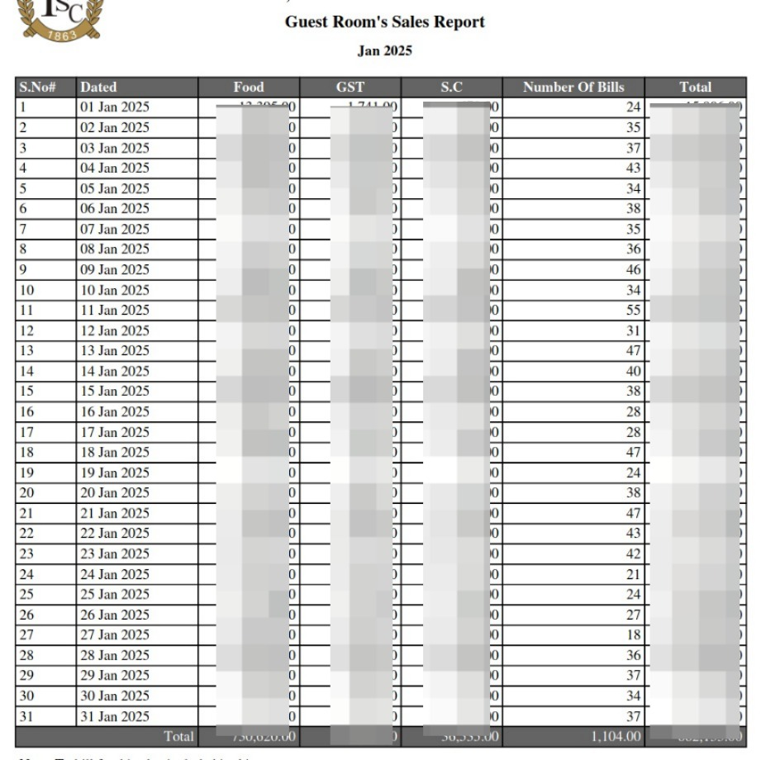
* Cancellation Report
  + 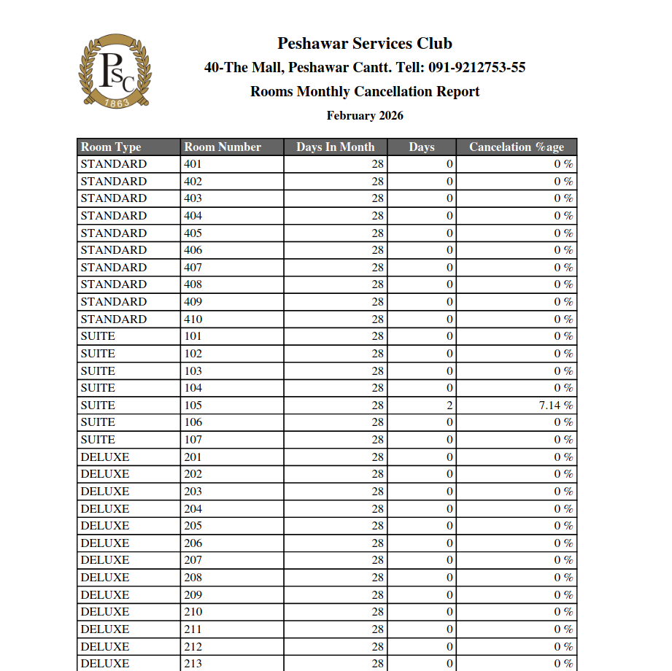
* Room Bills added to monthly bills (Total counts of user wise ’member/guest/Forces/Aff Club’ report), along with All list of member/Guest/Arm Forces/Aff Club (with club names).
  + 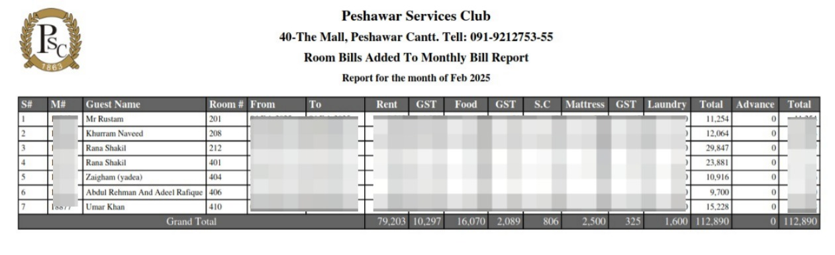
* Same view for Halls and Lawns

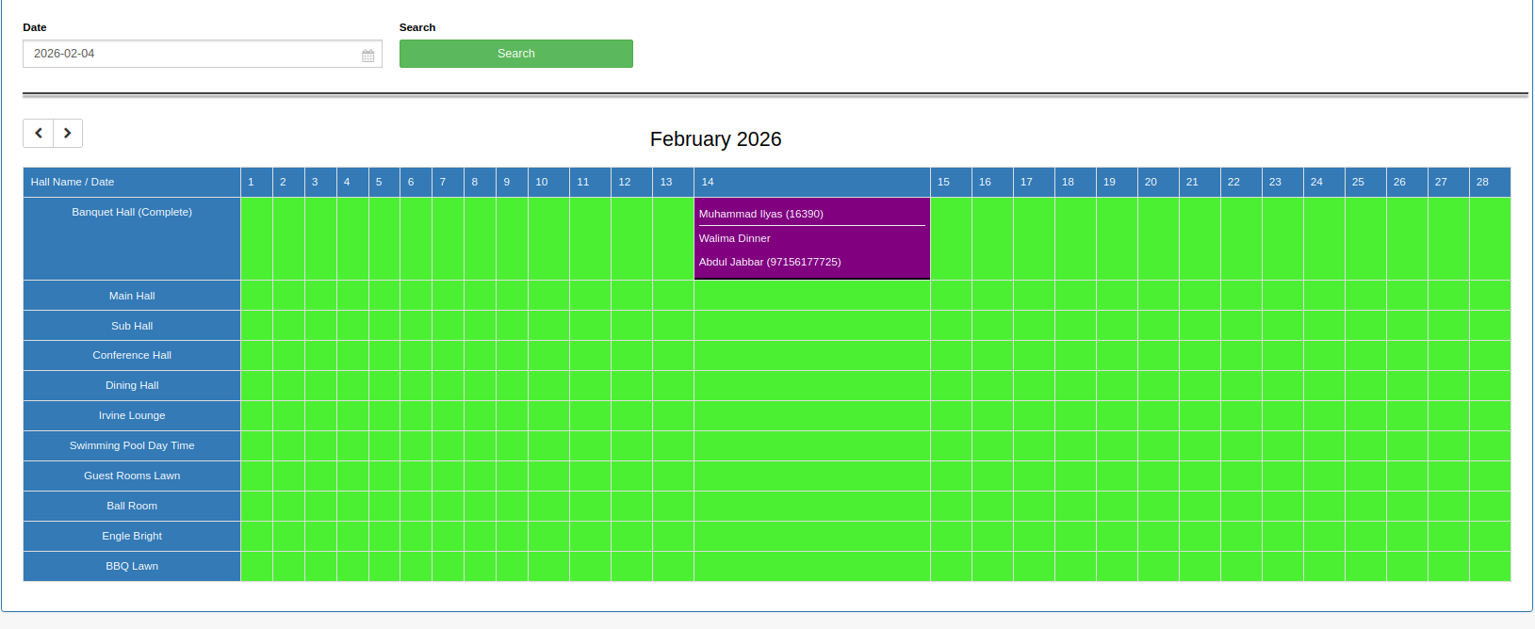

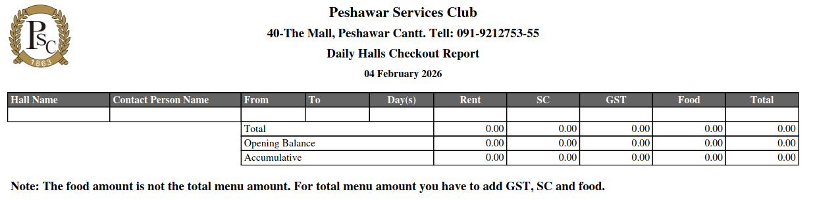

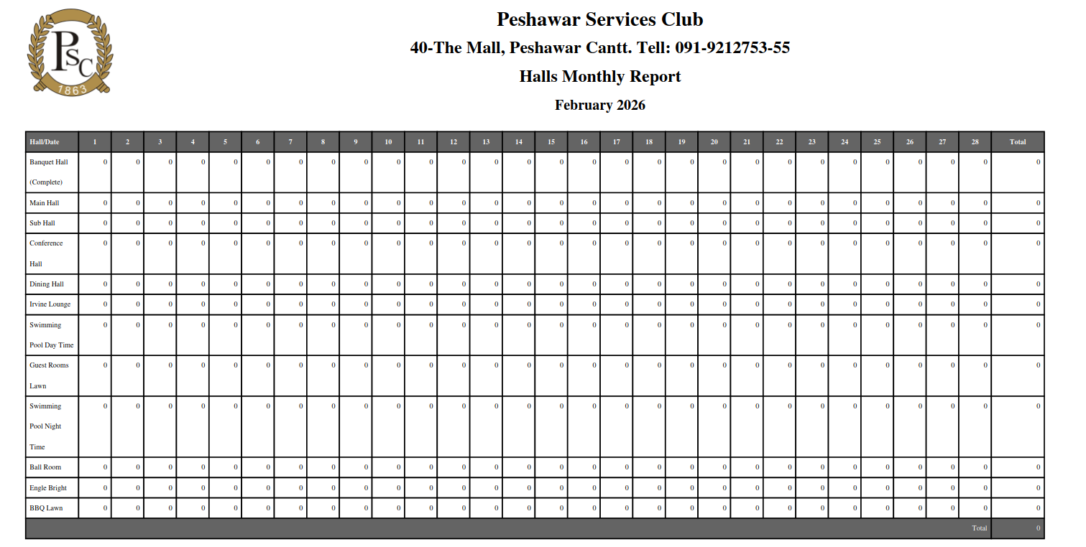

Halls booking multiple search Hall wise booking, + Event Type and Time wise and status (Booked/Canceled) wise, payment wise from and to date,Specific Hall wise user booked by wise (App/Admin), member no wise, canceled by wise, Booked for wise, can search with one or with combination of all fields and view the list, download as pdf an excel.

Photoshoot from and to date, (App/Admin), member no wise, canceled by wise, Booked for wise, can search with one or with combination of all fields and view the list, download as pdf an excel.

### **5) Facility Configuration**

* Set facility pricing & rules
* Block/unblock dates
* Lock rooms
* Cancellation policies
* Calendar management

### **6) Billing File Upload**

* Upload monthly arrears Excel (.xlsx)
* Required columns: Member ID, Month, Amount Due, Previous Balance, Status adn otehr basic information
* Validation + error report
* Historical archive.
* Member can pay bills using App and Kucik Pay chanel
* Reports of Bills along with member status wise and month wise.

### **7) Notifications Management**

* Create & schedule push notifications
* Target Users and all users
* Templates + delivery logs

### **8) Admin User Management**

* Create/deactivate admin users
* Reset/change passwords
* Login and activity history and module wise reports. Views can be downloaded.
* Super Admin only controls

### **9) Account**

* Integration of all transactions according to accounts standards and reports based on Cash, Kuick Pay, Online, By Card , Cheque wise reports along with transaction date and amount. **Final meeting will be arranged with our Accountant and Mobile app developer team for guaidance and necessary implementation will be performed in app as per his requirements.**

### **10) API for system communication of live server and Local System.**

* Real time Synchronization with local systems for reports and data sharing. (Send and receive data).
* Documentation

### **10) Dashboard.**

* Dashboard content is clickable and redirected to the concern data.
* Report for every booking based on searchable date, status categorywise which are received to that booking or modules.
* All Reports can be view as listing, download as pdf and excel format.
* Affiliated Club Reports count visit (search from and To date) and details listing report of all request visits. The report can be downloaded and printed. Also add Search and reports of Halls/Guest Rooms/Photoshoot total Counts and Details listing.Export data save data print data options in all reports.

Note all the Booking information must meet the requirements in case of any data edit modified and deleted cancelled.

## **Backend APIs (Common to App + Web)**

* OTP generation & verification
* JWT auth + RBAC middleware
* CMS CRUD APIs
* Booking APIs (availability, create, cancel, status)
* Quickpay payment APIs + webhook
* Auto‑cancellation scheduler
* Billing APIs + Excel processing
* Notification APIs + device tokens

## **1. Executive Summary**

### **1.1 Project Overview**

**The PSC project is a comprehensive digital solution consisting of:**

* **Mobile Application (React Native - Android & iOS)**
* **Web-based Admin Panel (Management Console)**

### **1.2 Target Users**

* **Primary Users: Approved PSC members only**
* **Administrative Users: Super Admin and Sub-Admins**
* **Access Control: No public signup; all users managed by Admin**

### **1.3 Core Objectives**

* **Enable members to book facilities (Guest Rooms, Banquet Halls, Photo Shoots)**
* **Provide centralized content and announcement management**
* **Integrate with QUICKPAY payment gateway for billing and payments**
* **Deliver real-time push-up notifications and updates**
* **Maintain comprehensive admin control over all operations**
* **No third-party cloud databases.**
* **All data stored on client's live server**

## **Testing & Quality Assurance**

### **7.1 Testing Scope**

**Platform Testing:**

* **Android devices (versions 8.0 to 13.0)**
* **iOS devices (versions 12.0 to latest)**
* **Mobile phones (various screen sizes)**

**Functional Testing:**

* **User registration and OTP login**
* **Role-based access control**
* **Content display and updates**
* **Facility booking end-to-end flow**
* **Payment integration (Quickpay)**
* **Monthly billing display**
* **Excel file upload and processing**
* **Push notification delivery**
* **Admin panel all features**
* **Real-time synchronization**
* **Configure UI/UX framework and styling system**

**Performance Testing:**

* **API response times**
* **App load time**
* **Large file uploads (Excel files)**
* **Concurrent user handling**
* **Database query optimization**

**Usability Testing:**

* **User interface intuitiveness**
* **Navigation flow**
* **Error message clarity**
* **Loading states and feedback**
* **Accessibility compliance**

### **7.2 User Acceptance Testing (UAT)**

* **Conducted with client stakeholders**
* **Test scenarios covering all user roles**
* **Real-world booking scenarios**
* **Payment flow verification**
* **Admin panel operations**
* **Feedback collection and implementation**
* **Sign-off before final delivery**

## 

## 

## **8. Deployment & Handover**

### **8.1 Deliverables**

|  |  |  |
| --- | --- | --- |
| **Deliverable** | **Format** | **Description** |
| **Mobile App - Android** | **APK File** | **Production-ready Android app** |
| **Mobile App - iOS** | **IPA File** | **Production-ready iOS app (for App Store submission)** |
| **Mobile App Source Code** | **ZIP/Git Repository** | **Complete React Native codebase** |
| **Admin Panel** | **Web URL + Source** | **Deployed web application + React.js code** |
| **Backend APIs** | **Deployed + Source** | **Node.js server code and API documentation** |
| **Database Schema** | **SQL File** | **Complete database structure with seed data** |
| **API Documentation** | **PDF/Postman Collection** | **All endpoint specifications** |
| **User Manuals** | **PDF Documents** | **End-user guide, Admin guide** |
| **Technical Documentation** | **PDF Document** | **Architecture, setup, deployment guides** |
| **Deployment Guide** | **PDF Document** | **Server setup, configuration, deployment steps** |

### 